TRAFFIC ACCIDENT ANALYSIS
Exploratory Data Analysis on Traffic Accident Dataset
AIM
To perform Exploratory Data Analysis (EDA) on a traffic accident dataset using Python and identify useful patterns based on time, location/area, severity, accident type, and vehicle type through data cleaning, analysis, and visualization.

DATASET
Dataset Description
The Traffic Accident dataset contains accident records with information about the date and time of occurrence, location/area, accident type, severity, and vehicle type.
Dataset Columns
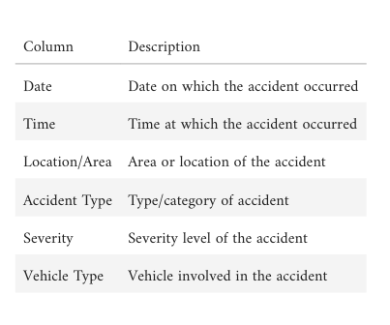
Dataset File
Traffic_Accident_Dataset.csv

OBJECTIVES
- To understand the structure of the Traffic Accident dataset.
- To identify missing values and duplicate records.
- To clean and convert date/time fields.
- To analyze accidents by time and identify accident trends
- To identify accident-prone locations/areas.
- To analyze accident severity distribution.
- To analyze accidents by vehicle type and accident type.
- To visualize important accident patterns using graphs.
- To write key observations from the analysis.

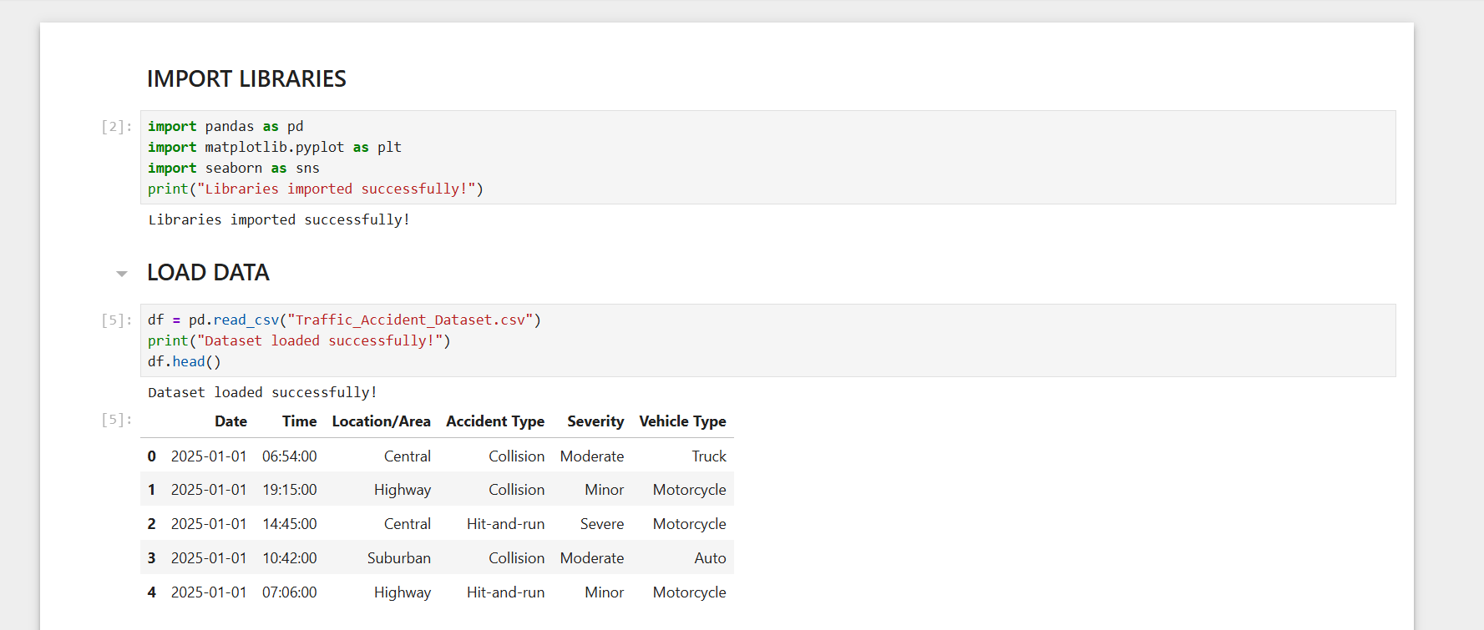
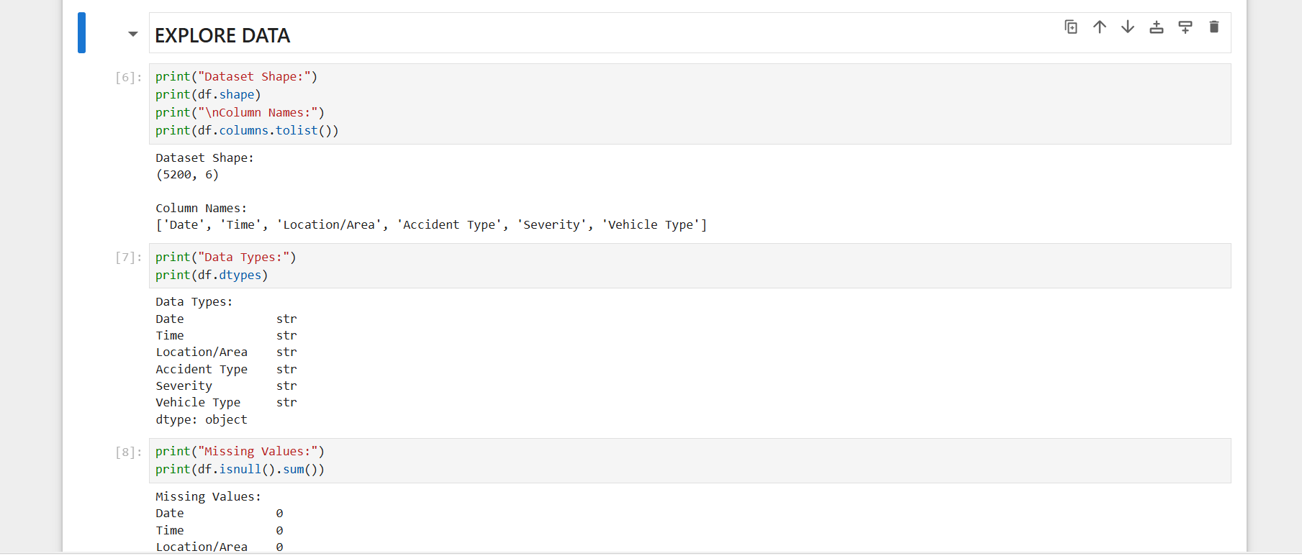
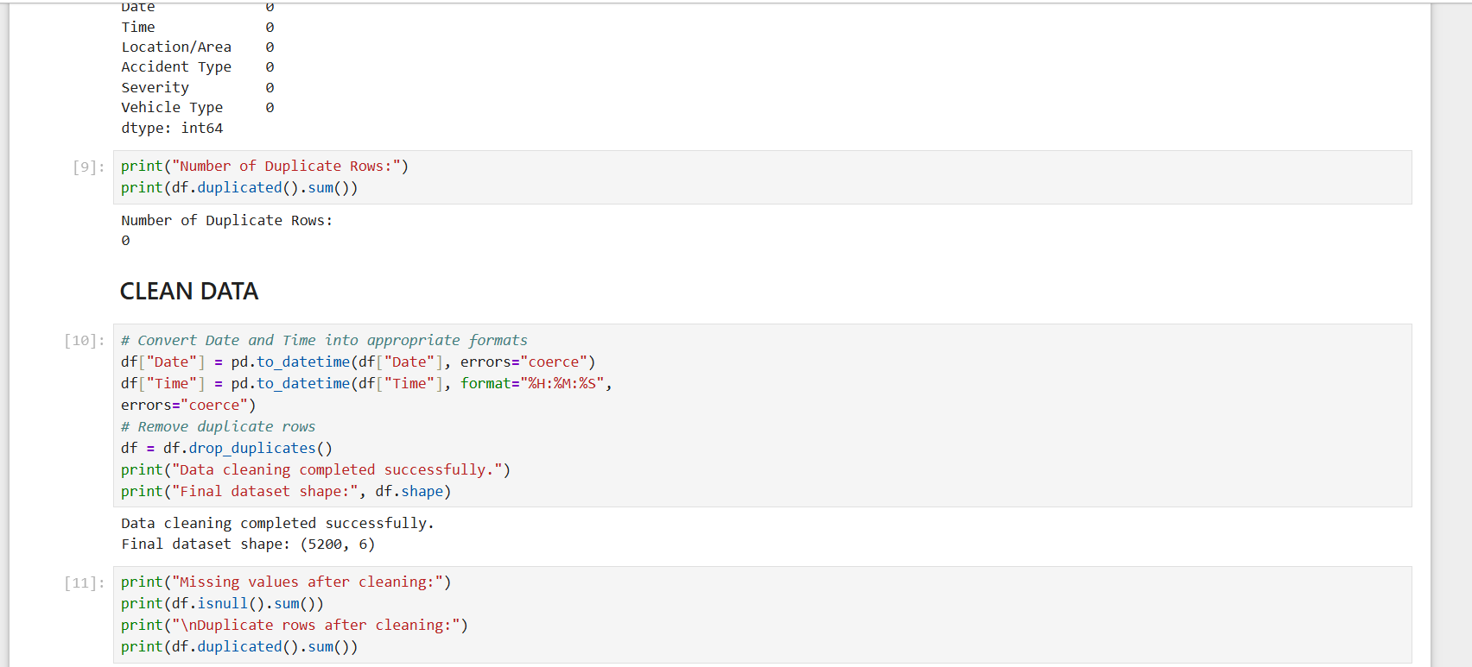
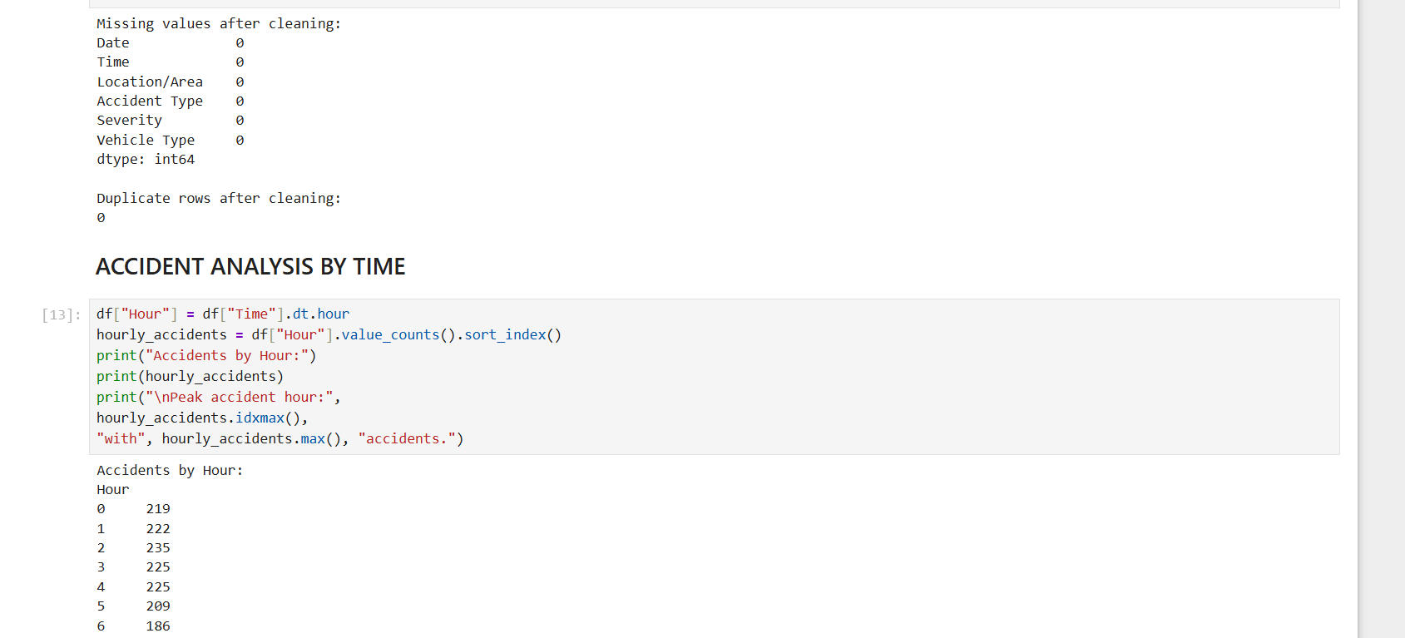
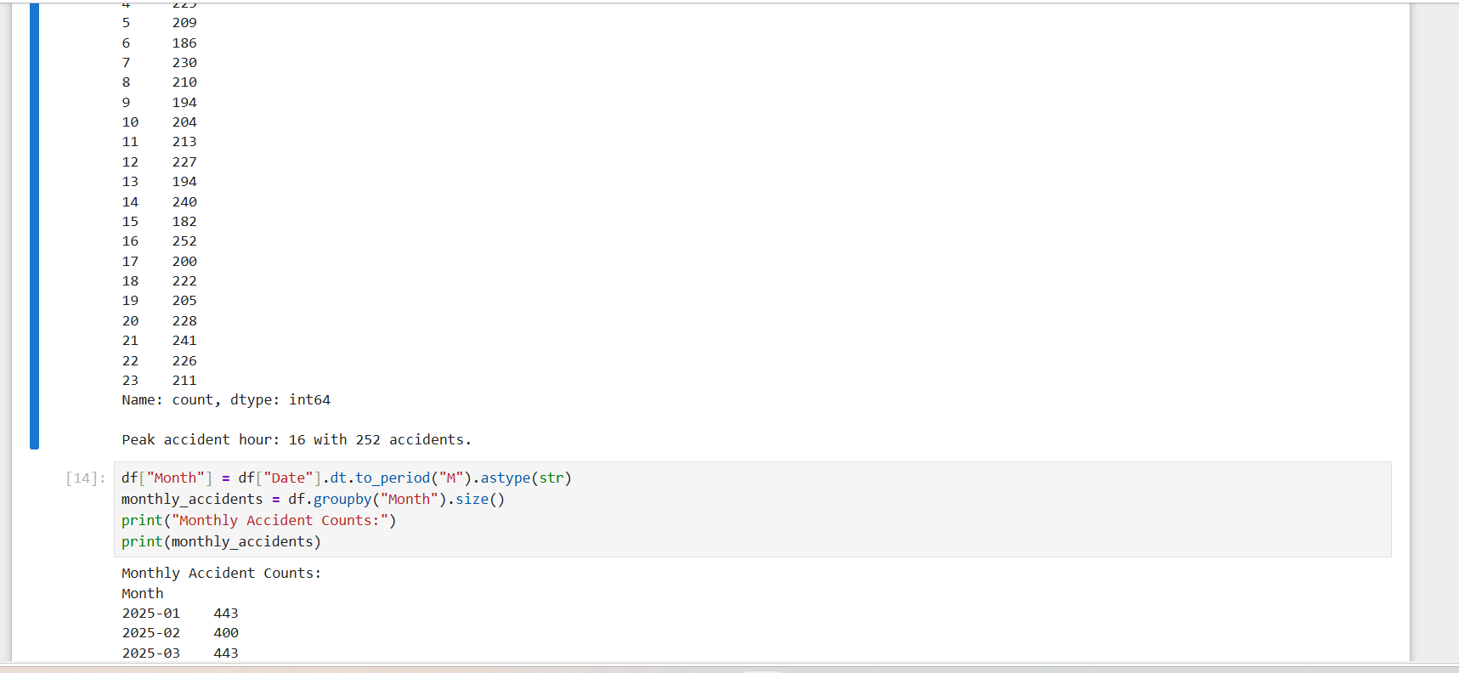
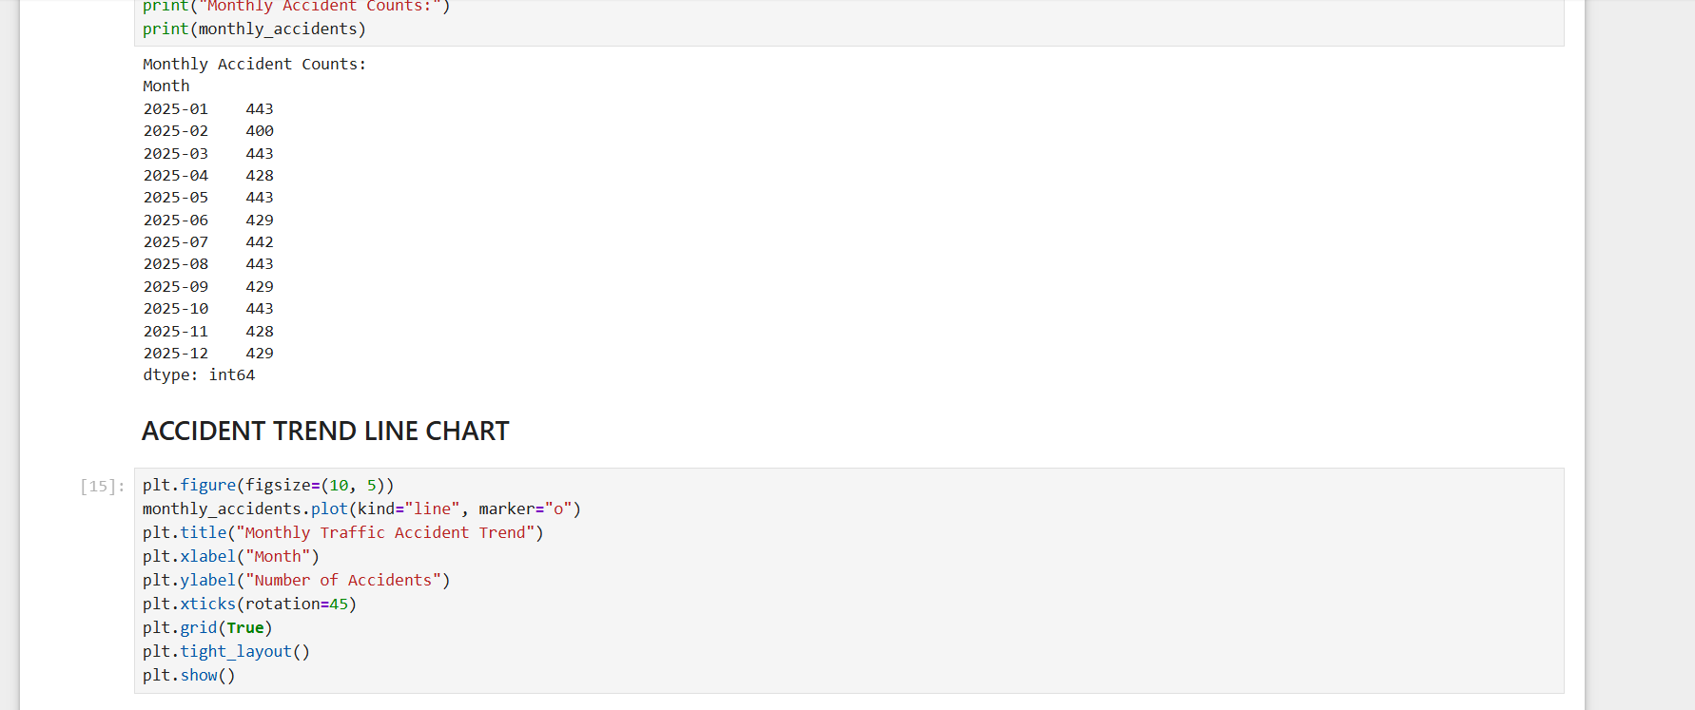
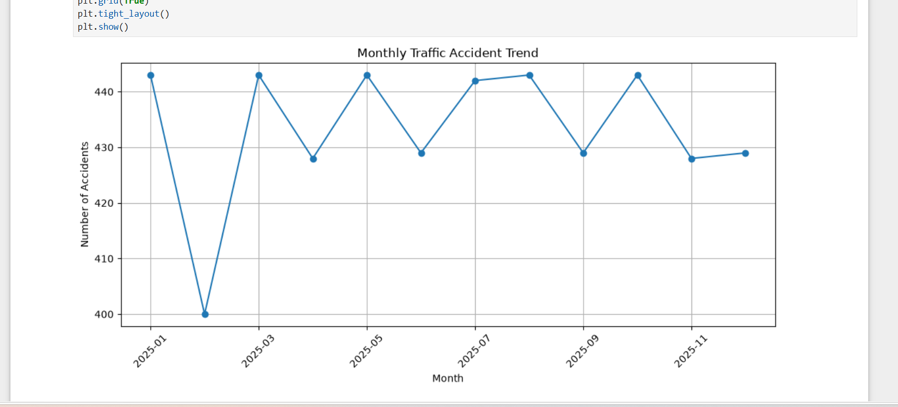
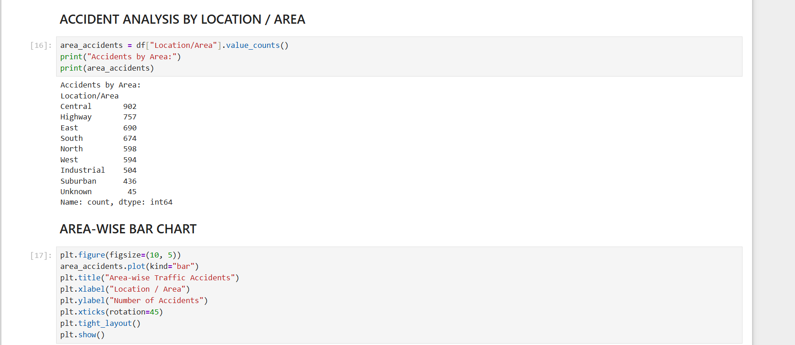
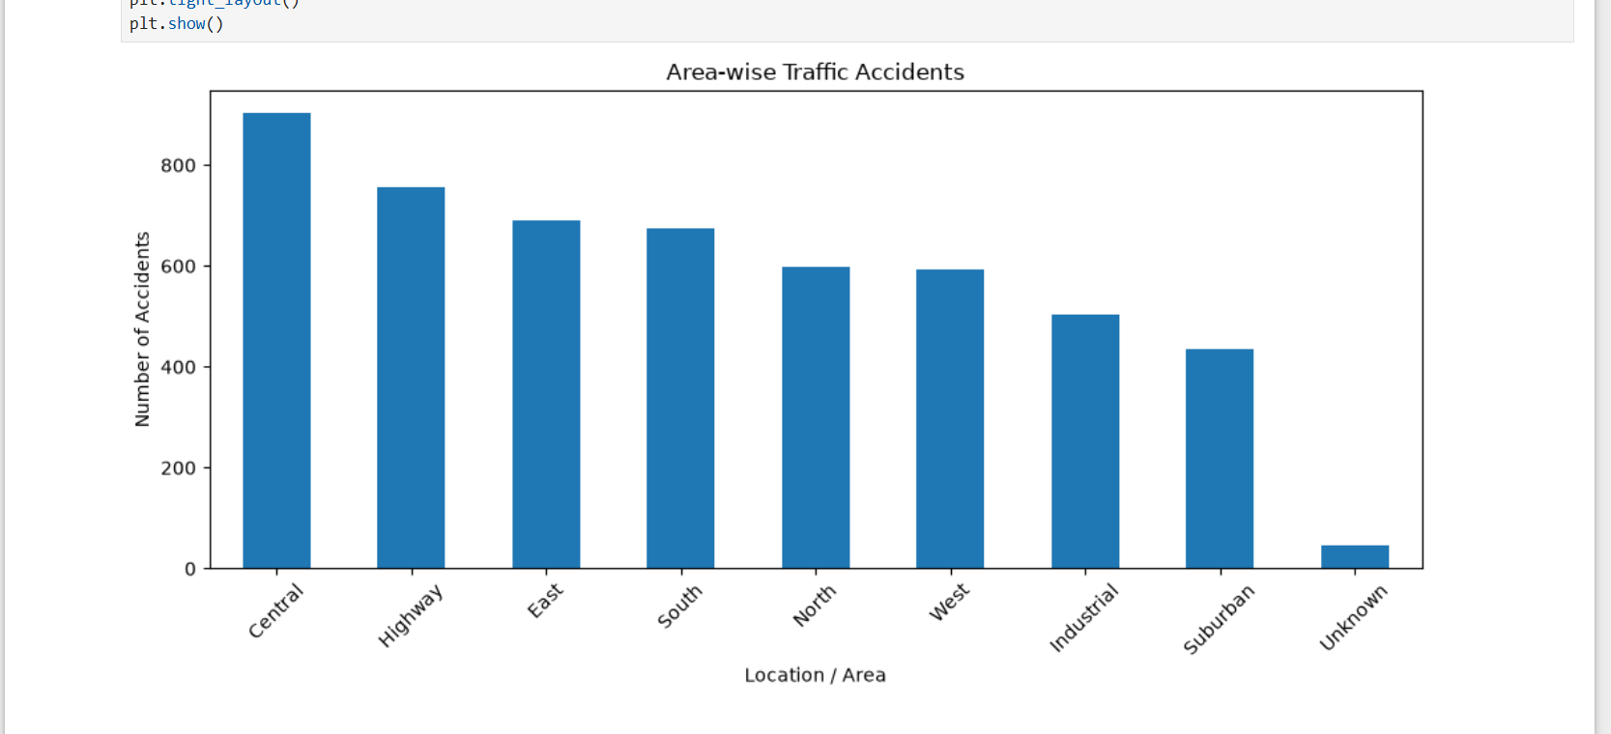
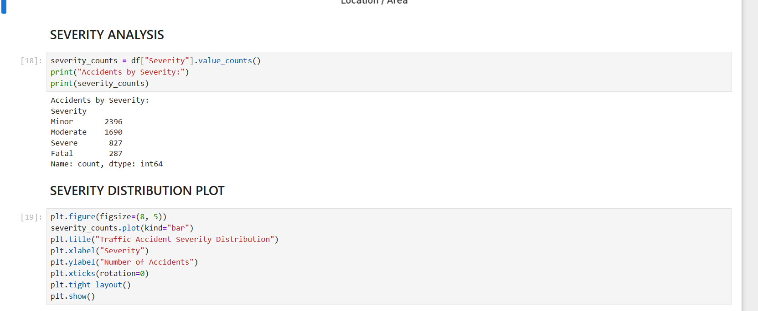
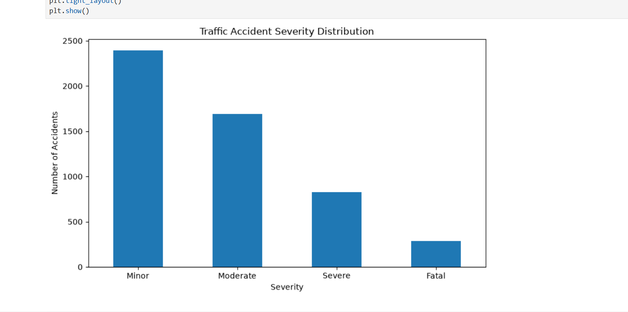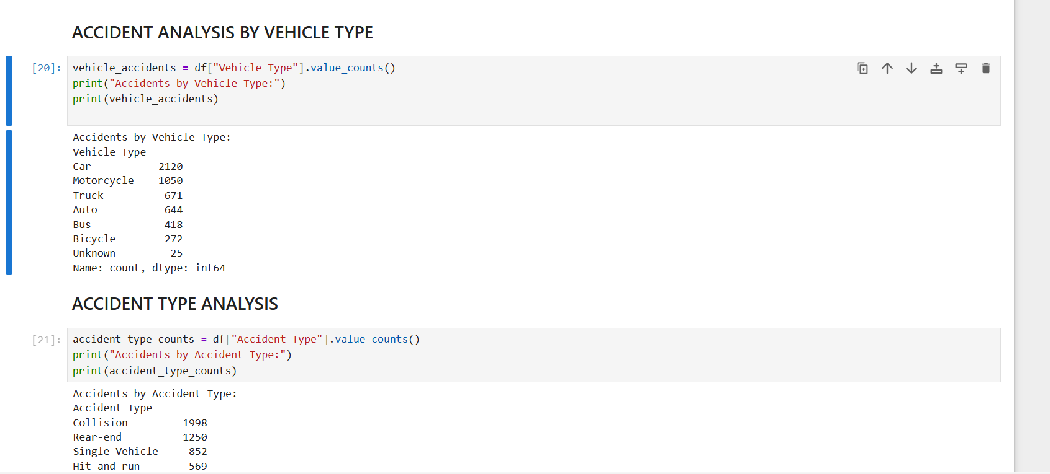
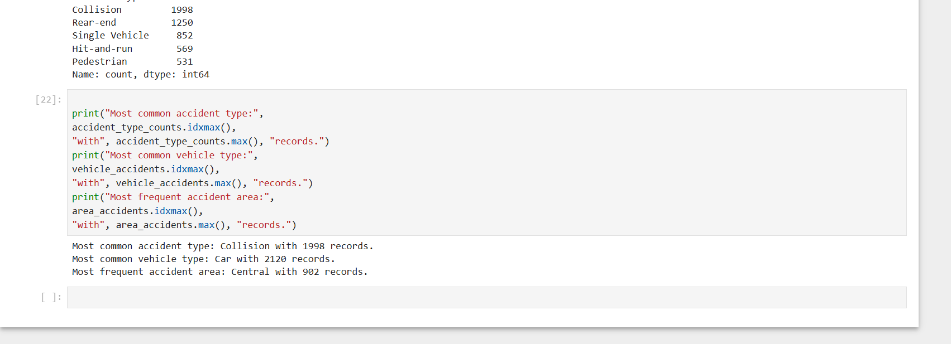
OBSERVATIONS
- The dataset contains 5,200 traffic accident records accident type, severity, and vehicle type. across six fields: date, time, location/area.
- The dataset contains no missing values and no duplicate records, so no rows were removed during duplicate handling.
- The Central area has the highest number of recorded accidents, while Suburban has fewer recorded accidents among the named areas.
- Minor accidents are the most common severity category, followed by Moderate, Severe, and Fatal accidents.
- Cars are the most frequently recorded vehicle type, and Collision is the most common accident type in the 5. dataset.

CONCLUSION
The Traffic Accident EDA project demonstrates how Python can be used to inspect, clean, analyze, and visualize accident data. The analysis identifies patterns across time, location, severity, vehicle type, and accident type. The trend line, area-wise bar chart, and severity distribution plot provide a clear visual summary of the major accident patterns in the dataset.

